**Project Report**

Diagnostics for Detecting Cardiovascular Abnormalities

**TEAM 3**

**Team Leader:**

G Pranava Sai 21R11A0515

**Team Members:**

A Harshith Sai 21R11A0504

G Harshit 21R11A0519

P Rohith 21R11A0537

**Exploratory Data Analysis**

1. **Variable Relationalship**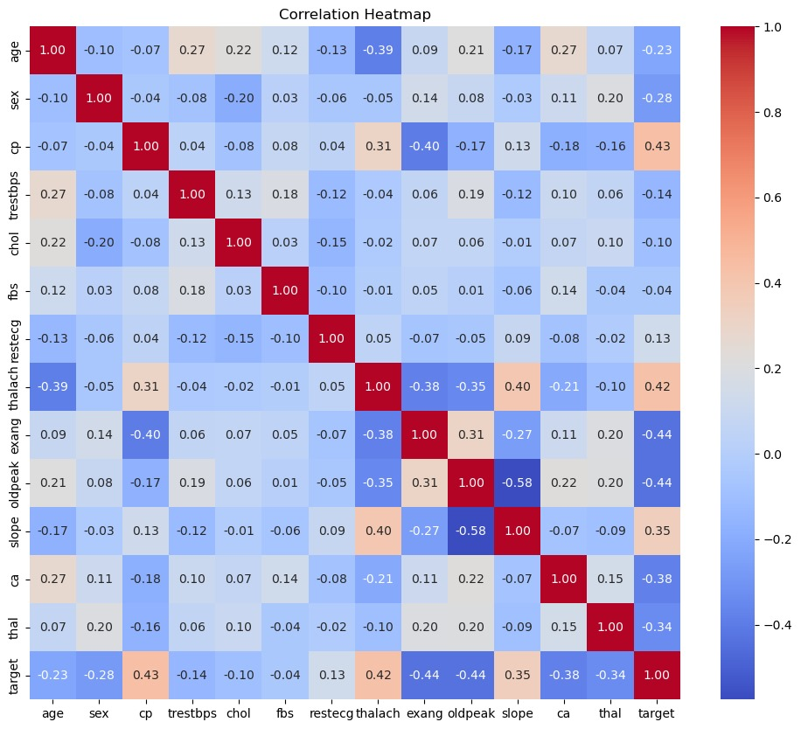

**Observation:**

The above diagram shows the heat map which shows the relationship between all the variables in the given dataset

**2.effect of cholostrol**

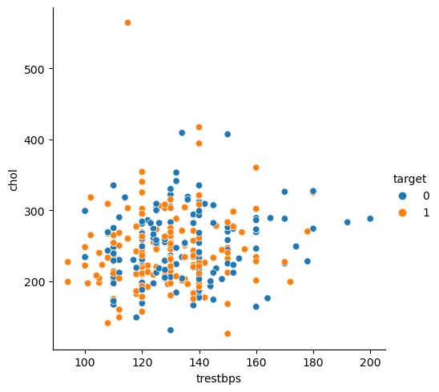

**Obsevation**:

The above shown relational plot describes the relationship between trestbps, chol and target. We can observe from the graph that there is a high possibility of heart disease as we can observe the chol variable shows target-1 (orange color) between the values 200 to 300.

**3.count vs age bar graph**

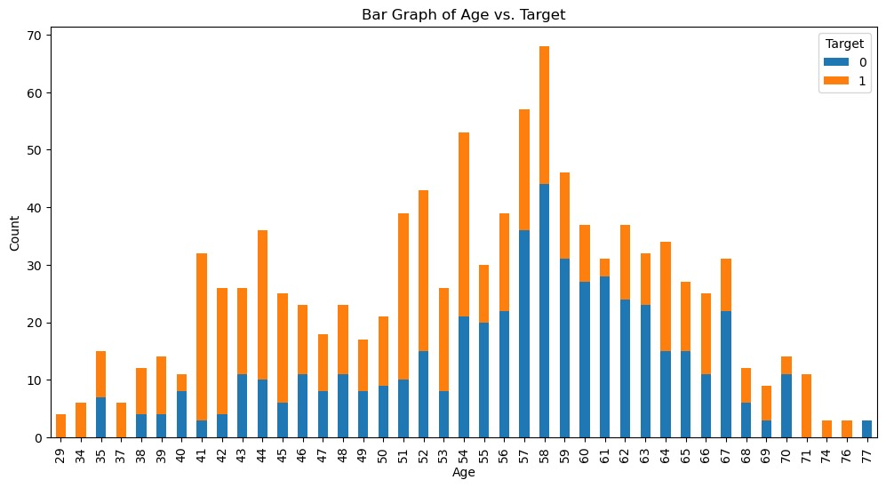

**OBSERVATION**

The above bar graph shows how the age factor effects on the heart disease on a person health. We can observe the maximum effect on the age between 40 to 60 years

**Here are observations and analysis about each transaction based on the provided data:**

**1. Transaction 1:**

- Age: 52, Sex: Male

- Resting blood pressure (trestbps): 125

- Cholesterol (chol): 212

- Fasting blood sugar (fbs): Normal

- Resting electrocardiographic results (restecg): Probable or definite left ventricular hypertrophy

- Maximum heart rate achieved (thalach): 168

- Exercise induced angina (exang): No

- ST depression induced by exercise relative to rest (oldpeak): 1

- Slope of the peak exercise ST segment (slope): Upsloping

- Number of major vessels (ca): 2

- Thalassemia (thal): Normal

- Probability of heart disease: 29.73%

**2. Transaction 2:**

- Age: 53, Sex: Male

- Resting blood pressure (trestbps): 140

- Cholesterol (chol): 203

- Fasting blood sugar (fbs): High

- Resting electrocardiographic results (restecg): Normal

- Maximum heart rate achieved (thalach): 155

- Exercise induced angina (exang): Yes

- ST depression induced by exercise relative to rest (oldpeak): 3.1

- Slope of the peak exercise ST segment (slope): Downsloping

- Number of major vessels (ca): 0

- Thalassemia (thal): Normal

- Probability of heart disease: 2.73%

**3. Transaction 3:**

- Age: 70, Sex: Male

- Resting blood pressure (trestbps): 145

- Cholesterol (chol): 174

- Fasting blood sugar (fbs): Normal

- Resting electrocardiographic results (restecg): Probable or definite left ventricular hypertrophy

- Maximum heart rate achieved (thalach): 125

- Exercise induced angina (exang): Yes

- ST depression induced by exercise relative to rest (oldpeak): 2.6

- Slope of the peak exercise ST segment (slope): Downsloping

- Number of major vessels (ca): 0

- Thalassemia (thal): Normal

- Probability of heart disease: 3.19%

**4. Transaction 4:**

- Age: 61, Sex: Male

- Resting blood pressure (trestbps): 148

- Cholesterol (chol): 203

- Fasting blood sugar (fbs): Normal

- Resting electrocardiographic results (restecg): Probable or definite left ventricular hypertrophy

- Maximum heart rate achieved (thalach): 161

- Exercise induced angina (exang): No

- ST depression induced by exercise relative to rest (oldpeak): 1

- Slope of the peak exercise ST segment (slope): Upsloping

- Number of major vessels (ca): 1

- Thalassemia (thal): Normal

- Probability of heart disease: 32.77%

**5. Transaction 5:**

- Age: 62, Sex: Female

- Resting blood pressure (trestbps): 138

- Cholesterol (chol): 294

- Fasting blood sugar (fbs): High

- Resting electrocardiographic results (restecg): Probable or definite left ventricular hypertrophy

- Maximum heart rate achieved (thalach): 106

- Exercise induced angina (exang): No

- ST depression induced by exercise relative to rest (oldpeak): 1.9

- Slope of the peak exercise ST segment (slope): Flat

- Number of major vessels (ca): 3

- Thalassemia (thal): Fixed defect

- Probability of heart disease: 13.33%

**Conclusion:**

- Among the provided transactions, Transaction 4 has the highest probability (32.77%) of having heart disease, followed by Transaction 1 (29.73%).

- Transaction 2 has the lowest probability (2.73%) of having heart disease.

- Transaction 3 and Transaction 5 have moderate probabilities (3.19% and 13.33% respectively).